Brianna De La Riva

Professor Heusser

Mobile Architect and Programming (CS-360)

28 February 2024

7-2 App Launch Plan

During the launch of the app, the description would entail a concise intro of the features, uses, and benefits the application has. It would include the various purposes one may have for this app in tracking weight, and include what type of users may find it useful. Since the description would be viewed by a large portion of non-technical people who browse the Google Play store, I would ensure the language is simplified during the description and reader-friendly for all ages. Within the app description, I would also include a brief process on how the application is easy to use and how to. If possible, I would include a few screenshots of the UI as well so users can have a visualization.

As for the icon choice, I would find an icon that is relatable to what the application does. Since the application has a weight-tracking focus, I would choose something like a little weight scale for the icon. A similar example I found would be like below, I like it because it has some contrasting neutral colors and clearly demonstrates what the application can be used as:

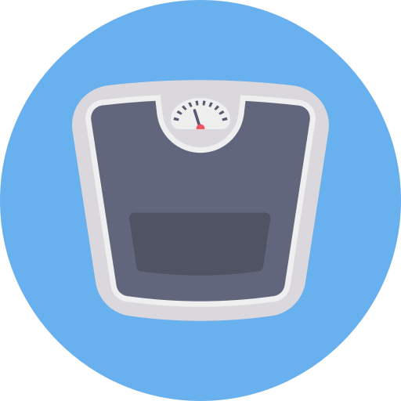 (Photo courtesy, Flaticon, 2020)

The weight tracking app would run on Android version 27 or newer to ensure it can be used by both older and newer devices with up-to-date Android API’s. This helps maintain a larger audience for being able to use the app, as well as different available features to potentially use, such as the Google Play App Bundling.

As for the permissions, the application will ask if the user would like to receive notifications and the user may allow or deny. While this is not a necessary permission to accept from the user to utilize the app, it will be helpful to keep the user on track for tracking their daily weight. Aside from this, the user will not be asked for other permissions since it will not be necessary.

Regarding the monetization of the app, I would select the use of advertisements within the app that pop up upon opening the app and last for about 15 seconds. However, if a user would like to remove advertisements, they would be able to pay a small one-time fee to remove the ads and have an ad-free experience.

References

Flaticon. (2020, September 4). *Weight scale Icon - 3456484*. https://www.flaticon.com/free-icon/weight-scale_3456484